INTRODUCTION

Introduction:
In today’s digital era, Artificial Intelligence (AI)-powered chatbots are transforming how institutions interact with visitors and guests. Colleges often receive numerous inquiries regarding admission procedures, exam schedules, campus facilities, and other general queries. Handling these queries manually can be time-consuming and inefficient. This project, "Design and Development of College Chatbot for Visitors/Guests Using Python," aims to provide an AI-driven chatbot that offers instant and accurate responses, reducing dependency on human intervention.
By integrating Natural Language Processing (NLP), speech recognition, and text-to-speech capabilities, the chatbot enhances user experience by enabling both text and voice-based interactions. Developed using Python and Streamlit, this chatbot provides real-time assistance and improves accessibility for visitors.

1.1 Overview
The college chatbot is designed to assist visitors and guests by answering frequently asked questions related to the institution. The system utilizes TF-IDF vectorization and a Logistic Regression classifier to process and classify user queries efficiently. It also incorporates speech recognition for voice input and text-to-speech (TTS) for verbal responses.

Key Features:
- Text and voice-based communication for seamless interaction.
- Automated query handling for FAQs such as admission details, exam schedules, and campus facilities.
- AI-driven classification of user inputs for accurate responses.
- User-friendly interface with a simple chatbot interface using Streamlit.
This chatbot reduces the burden on college administration by providing instant responses, thereby enhancing visitor experience and operational efficiency.

1.2 Existing System
In the current scenario, most colleges rely on manual methods to handle visitor and guest queries, such as:
- Help desks staffed by college representatives.
- Emails and phone calls for query resolution.
- Static FAQs on college websites.

Limitations of the Existing System:
- Time-consuming as visitors have to wait for responses.
- Limited availability since human support is not available 24/7.
- Lack of scalability when handling multiple queries simultaneously.
- No voice interaction, making it inaccessible for some users.
These drawbacks highlight the need for an automated and AI-driven chatbot that offers instant, interactive, and efficient query resolution.

1.3 Proposed System
The proposed system introduces an AI-based chatbot that allows visitors and guests to interact via text and voice commands. The chatbot is designed to understand user queries, process them using NLP techniques, and provide relevant responses instantly.

Advantages of the Proposed System:
- Automated Query Handling: Instantly responds to frequently asked questions.
- 24/7 Availability: Visitors can get information anytime without human intervention.
- Voice Recognition: Users can communicate using speech, improving accessibility.
- Text-to-Speech Output: Provides verbal responses for a more interactive experience.
- Scalable & Customizable: More queries and features can be added over time.
By implementing this chatbot, the college can enhance visitor experience, improve operational efficiency, and provide a modern AI-driven solution for handling inquiries.

LITERATURE SURVEY

2.1 Literature Survey
The development of AI-powered chatbots has been an active area of research, particularly in education, where they assist in information retrieval, query resolution, and interactive learning. This literature survey explores various research contributions related to chatbot development, Natural Language Processing (NLP), voice recognition, and machine learning techniques used for improving chatbot efficiency.

2.1 Chatbots in Education
Chatbots have been widely adopted in the educational domain to provide real-time support for students, visitors, and faculty members. Several studies highlight the effectiveness of AI chatbots in enhancing communication and reducing administrative workload.

Key Studies:
- S. Adamopoulou & L. Moussiades (2020) - Explored the use of chatbots in education and concluded that AI-driven chatbots significantly improve user engagement and provide instant access to information.
- A. Hussain et al. (2019) - Analyzed the impact of chatbots in higher education institutions and found that NLP-based chatbots improved response accuracy and reduced dependency on human administrative support.
- P. Winkler & S. Söllner (2018) - Investigated chatbot usability in universities and highlighted the need for personalized AI-driven chatbots to address specific institutional queries effectively.

2.2 Natural Language Processing (NLP) for Chatbots
NLP plays a crucial role in understanding and processing human language to enable meaningful conversations between users and chatbots. Various machine learning models and vectorization techniques have been employed for chatbot development.

Key Research Contributions:
- Manning et al. (2014) - Introduced TF-IDF (Term Frequency-Inverse Document Frequency), a feature extraction method widely used in text classification, including chatbot intent recognition.
- Jurafsky & Martin (2021) - Provided insights into machine learning techniques for NLP, emphasizing Logistic Regression and Support Vector Machines (SVM) for intent classification in chatbot systems.
- Howard & Ruder (2018) - Developed the ULMFiT (Universal Language Model Fine-tuning for Text Classification), which significantly improved chatbot response accuracy by leveraging pre-trained deep learning models.

2.3 Voice Recognition & Text-to-Speech (TTS) Integration
Voice-enabled chatbots improve accessibility, allowing users to interact through speech. Various speech recognition models and TTS engines have been integrated into chatbot development.

Key Research Contributions:
- Google Speech API & IBM Watson (2019) - Provided high-accuracy speech-to-text conversion, enabling real-time voice input processing in chatbot systems.
- P. Taylor (2009) - Explored Text-to-Speech (TTS) synthesis, discussing advancements in AI-driven voice output for interactive chatbot communication.
- Baidu Deep Speech (2018) - Demonstrated the use of deep learning models for high-accuracy speech recognition, reducing errors in chatbot voice input interpretation.

2.4 Machine Learning Algorithms for Chatbot Development
Several machine learning models have been employed to improve chatbot performance in intent recognition, response generation, and query handling.

Key Research Contributions:
- Nguyen et al. (2019) - Compared various machine learning models, concluding that Logistic Regression and Random Forest offer high accuracy in chatbot intent classification when combined with TF-IDF.
- Devlin et al. (2018) - Introduced BERT (Bidirectional Encoder Representations from Transformers), significantly improving chatbot understanding of complex user queries.
- Zhang et al. (2020) - Proposed hybrid approaches combining deep learning with rule-based models, improving chatbot adaptability and response relevance.

The literature review indicates that AI-driven chatbots enhance user interaction, improve response accuracy, and reduce human workload in educational institutions. Key advancements in NLP, speech recognition, and machine learning have significantly improved chatbot capabilities, making them more efficient and accessible.
Our project leverages these research findings by implementing a TF-IDF-based intent classification system, speech recognition, and text-to-speech functionalities to develop a smart, voice-enabled chatbot for college visitors and guests.

SYSTEM ANALYSIS

3.1 Feasibility Study

A feasibility study assesses the viability of developing the chatbot based on technical, operational, economic, and legal aspects.

3.1.1 Technical Feasibility

The chatbot uses Python, NLP (Natural Language Processing), and Machine Learning (ML) to process user queries.

It integrates Speech Recognition (Google Speech API) and Text-to-Speech (pyttsx3) for voice-based interaction.

The system is developed using Streamlit for a user-friendly web interface.

3.1.2 Operational Feasibility

The chatbot provides quick and accurate responses to visitor queries.

It reduces the need for human intervention in answering frequently asked questions (FAQs).

The system ensures 24/7 availability for users.

3.1.3 Economic Feasibility

Low development cost – Uses open-source libraries like NLTK, scikit-learn, and Streamlit.

No additional hardware required – Can run on any standard server or local machine.

3.1.4 Legal Feasibility

The chatbot adheres to privacy policies and ensures secure handling of user data.

It does not store sensitive personal data, making it compliant with data protection regulations.

3.2 Functional Requirements

The functional requirements define the core features and operations of the chatbot.

3.2.1 User Interaction

Users can input text queries or speak to the chatbot using voice recognition.

The chatbot processes and returns relevant responses based on intent classification.

3.2.2 Intent Classification

Uses TF-IDF vectorization and Logistic Regression to categorize user queries.

3.2.3 Response Mechanism

Generates responses based on a predefined set of patterns and responses.

Uses Text-to-Speech (TTS) to provide voice-based replies.

3.2.4 Error Handling

Displays an error message if the chatbot fails to recognize speech or text.

3.2.5 Exit Handling

Ends the conversation when the user types "bye" or "exit".

3.3 Non-Functional Requirements

The non-functional requirements ensure system performance, security, and usability.

3.3.1 Performance Requirements

The chatbot should provide instant responses with minimal processing time.

The system should handle multiple concurrent user interactions.

3.3.2 Security Requirements

Ensures data privacy by not storing personal information.

Protects against unauthorized access and misuse.

3.3.3 Usability Requirements

The chatbot should have a simple and interactive UI.

The voice feature should recognize multiple accents and pronunciations.

3.3.4 Reliability Requirements

The chatbot should function without frequent failures or downtime.

3.4 System Requirements

The system requirements specify the hardware and software needed to run the chatbot efficiently.

3.4.1 Hardware Requirements

Processor: Intel Core i3 or higher

RAM: Minimum 4GB (8GB recommended)

Storage: At least 10GB free space

Microphone: For voice input processing

3.4.2 Software Requirements

Operating System: Windows / macOS / Linux

Programming Language: Python 3.x

Libraries & Frameworks:

NLTK (Natural Language Processing)

scikit-learn (Machine Learning)

Streamlit (User Interface)

SpeechRecognition (Voice Input)

pyttsx3 (Text-to-Speech)

Development Environment: Jupyter Notebook / VS Code / PyCharm

3.4.3. Network & Deployment Requirements
- High-speed internet (for cloud-based training or real-time data transfer).
- Edge computing for processing video in real-time without cloud dependency.
- Autonomous vehicle integration (optional) via ROS (Robot Operating System).

SOFTWARE ENVIRONMENT
4.1 Operating System
The system is designed to be compatible with major operating systems to ensure cross-platform functionality.
Operating System | Version | Purpose
Windows | 10/11 (64-bit) | Development, Testing, and User Execution
macOS | Monterey/Ventura | Development & User Execution
Linux | Ubuntu 20.04+ | Deployment & High-Performance Computing
Cloud Platforms | AWS, Google Cloud, Azure | Large-Scale Deployment
Justification:
- Linux-based systems (Ubuntu) are preferred for deep learning due to better GPU support.
- Windows & macOS are suitable for development, testing, and local execution.
- Cloud platforms provide scalable, high-performance processing.

4.2 Programming Language
The project primarily utilizes Python due to its vast ecosystem and extensive support for deep learning, artificial intelligence, and computer vision applications.

Explanation of Python Imports in the Chatbot Code
The given Python script imports various libraries to support natural language processing (NLP), speech recognition, and machine learning. Below is a detailed explanation of each import statement:

1. os (Operating System Interface)
- The os module allows interaction with the operating system.
- It is used to handle file paths, environment variables, and system commands.
- In the chatbot, it is used for managing the NLTK data directory.

2. nltk (Natural Language Toolkit)
- NLTK is a natural language processing (NLP) library for text analysis, tokenization, and classification.
- The chatbot uses NLTK for text preprocessing.

3. ssl (Secure Sockets Layer)
- SSL is used for secure internet connections.
- Here, it is used to bypass SSL verification when downloading NLTK datasets.

4. streamlit (Web UI Framework)
- Streamlit is a Python library for creating interactive web applications.
- It is used to display the chatbot UI and take user input.

5. random (Random Number Generation)
- The random module is used to randomly select chatbot responses from a list.

6. pyttsx3 (Text-to-Speech)
- pyttsx3 is a text-to-speech (TTS) library that allows the chatbot to speak responses.

7. speech_recognition (Speech-to-Text)
- speech_recognition is used to convert spoken words into text.

8. sklearn.feature_extraction.text.TfidfVectorizer (Text Vectorization)
- TfidfVectorizer converts text into numerical vectors for machine learning models.

9. sklearn.linear_model.LogisticRegression (Machine Learning Model)
- LogisticRegression is a classification algorithm used for predicting chatbot responses based on user input.

Each imported module plays a specific role in the chatbot:
- os → Handles file paths.
- nltk → Processes text (tokenization, NLP).
- ssl → Bypasses SSL errors.
- streamlit → Creates a web-based UI for chatbot interaction.
- random → Randomly selects chatbot responses.
- pyttsx3 → Converts text responses into speech.
- speech_recognition → Converts voice input to text.
- TfidfVectorizer → Transforms text into numerical format for ML.
- LogisticRegression → Predicts chatbot responses using ML.

- Python:
Easy to learn and use – Python’s simple syntax makes it accessible.
Extensive library support – Python has built-in support for image processing, video analysis, and machine learning.
Cross-platform compatibility – Python code runs on Windows, Linux, and macOS.
Active community support – Python is open-source and widely used in AI and CV applications.

4.3 Development Frameworks & Libraries

To build an efficient and interactive chatbot, the following frameworks and libraries are used:

Natural Language Processing (NLP)

NLTK (Natural Language Toolkit) – Tokenization & processing

scikit-learn – Machine learning & intent classification

SpeechRecognition – Converting voice input to text

Machine Learning & Data Processing

TfidfVectorizer – Converts text into numerical format for ML

LogisticRegression – Classifies user queries based on trained data

Text-to-Speech (TTS)

pyttsx3 – Converts chatbot responses into speech

Web Framework & UI

Streamlit – For building an interactive chatbot UI

4.4 Integrated Development Environments (IDEs) & Tools
For efficient coding and debugging, the following IDEs and tools are recommended:
Tool | Purpose
VS Code / PyCharm | Writing and debugging Python code
Jupyter Notebook | Prototyping and testing deep learning models
Google Colab | Cloud-based training with free GPU access
Docker | Containerization for deployment

4.5 GPU & Hardware Acceleration Support
- The software environment supports CUDA (Compute Unified Device Architecture) for GPU acceleration.
- NVIDIA cuDNN (CUDA Deep Neural Network Library) is required for training deep learning models efficiently.
- TensorFlow-GPU or PyTorch with CUDA is used for accelerated training and inference.
- CPU Acceleration – Runs efficiently on Intel/AMD processors
For optimal performance, a dedicated NVIDIA GPU (RTX 3080 or higher) is recommended.

4.6 Deployment Environment
The system can be deployed in different environments:
- Local Deployment
  - Running the software on a local machine with GPU support.
  - Suitable for development and testing.
- Cloud Deployment
  - Using Google Cloud, AWS, or Azure for large-scale model training.
  - Recommended for training deep learning models that require high computational power.
- Embedded Deployment
  - Deploying the model on autonomous vehicles or edge devices (e.g., NVIDIA Jetson Nano, Raspberry Pi with Coral TPU).
  - Useful for real-time processing in self-driving applications.

SYSTEM DESIGN
5.1 Input Design

5.2 Output Design

5.3 Data Flow Diagram
A Data Flow Diagram (DFD) represents the flow of data through the chatbot system, illustrating inputs, processes, storage, and outputs.
User Input Processing
- Accepts text input via a text field or speech input via a microphone.
- Converts speech to text (if necessary).
Preprocessing & NLP
- Tokenization, Stopword Removal (NLTK).
- TF-IDF Vectorization for text understanding.
Machine Learning Model Processing
- Predicts intent using Logistic Regression.
- Fetches the most suitable response.
Response Generation
- Displays response as text.
- Converts response to speech (if enabled).
Output to User
- Sends the final response back to the user.

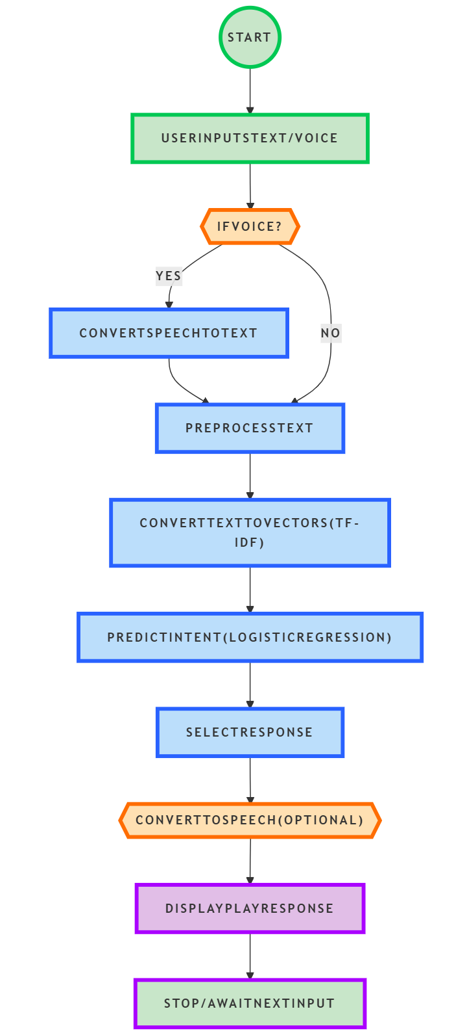

5.4 UML Diagram
5.4.1 Introduction
The Unified Modeling Language (UML) is a standardized visual representation used to model the structure and behavior of a system. It helps in understanding system components, interactions, and workflows before implementation.
For the College Chatbot for visitors/guests, we use UML diagrams to represent different aspects of the system, including Use Case Diagrams, Class Diagrams, Sequence Diagrams, and Activity Diagrams.

Purpose of UML Diagrams
- Visualize system components and their interactions.
- Identify functionalities and user interactions.
- Improve design clarity and software maintainability.
- Provide a blueprint for system implementation.

Types of UML Diagrams for This System
- Use Case Diagram – Represents the user interactions with the system.
- Class Diagram – Defines the structure of the system, including classes, attributes, and relationships.
- Sequence Diagram – Shows the flow of interactions between system components over time.
- Activity Diagram – Represents the workflow and logical sequence of operations.
Each diagram provides a different perspective on the College Chatbot for visitors/guests Using Python, ensuring a complete understanding of the functional and structural aspects.

5.4.1.1 Use Case Diagram

Explanation of the Use Case Diagram:
- Send Text Query (UC1): The visitor/guest enters a text message into the chatbot.
- Send Voice Query (UC2): The visitor/guest speaks, and the chatbot converts speech to text.
- Process Query (UC3): The chatbot uses NLP and machine learning to analyze the input.
- Generate Response (UC4): The chatbot determines the appropriate reply.
- Provide Text Response (UC5): The chatbot displays the response as text.
- Provide Voice Response (UC6): The chatbot converts text to speech and speaks the response.
This Use Case Diagram visually represents the interaction between Visitors/Guests and the College Chatbot System.
This diagram visually represents how the system functions and the interactions of different users.
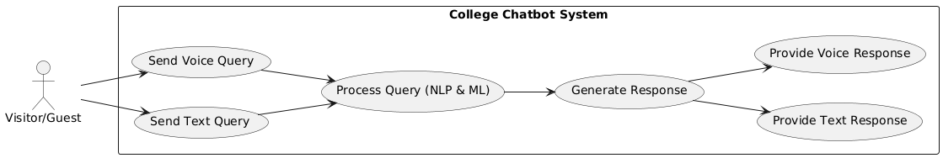

5.4.1.2 Class Diagram

Explanation of the Class Diagram:
- User: Represents the visitor/guest interacting with the chatbot.
- Chatbot: Core system processing user inputs and generating responses.
- NLPProcessor: Handles text processing using TfidfVectorizer and LogisticRegression.
- SpeechModule: Manages speech synthesis (pyttsx3) and recognition (speech_recognition).
- UI: Provides input fields and displays chatbot responses.
This Class Diagram defines the system’s key components and their relationships, making it easier to understand the software structure.
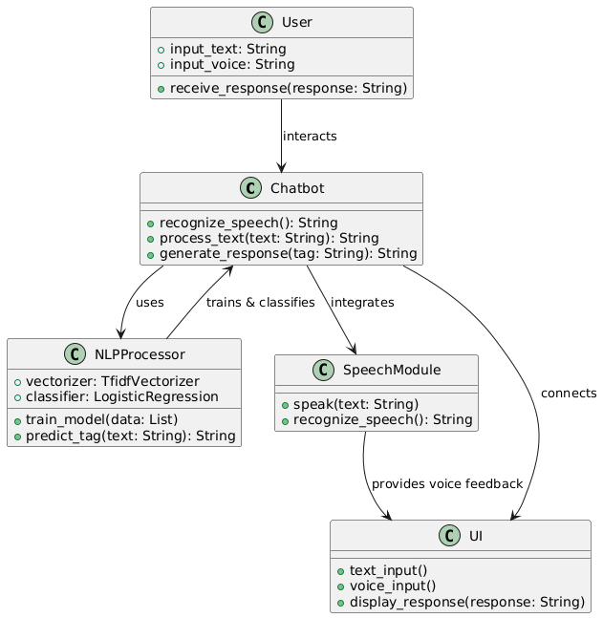

5.4.1.3 Sequence Diagram

Explanation of the Sequence Diagram:
- User provides input (text or voice).
- Chatbot UI processes input and, if voice is used, sends it to Speech Module.
- Speech Module converts voice to text and returns it to UI.
- UI forwards text input to NLP Processor.
- NLP Processor queries the Database for relevant responses.
- Database sends data back to the NLP Processor.
- NLP Processor generates a chatbot response and returns it to UI.
- UI displays the response and, if voice output is enabled, sends it to Speech Module.
- Speech Module converts text to speech and speaks the response.
This Sequence Diagram effectively captures the interactions between the system components.
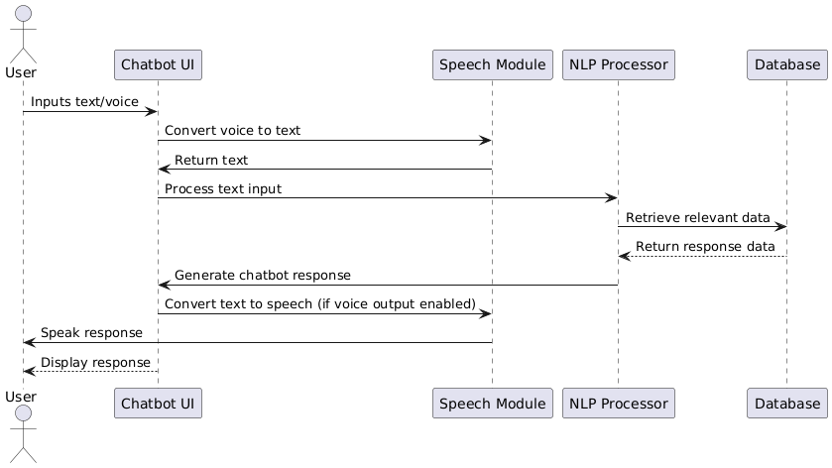

5.4.1.4 Activity Diagram

Explanation of the Activity Diagram:
- User inputs text or voice.
- If the input is voice, it is converted to text.
- The input is processed using NLP (Natural Language Processing).
- If a matching response is found in the database, it retrieves the response; otherwise, it returns a fallback response.
- The response is displayed to the user.
- If voice output is enabled, the response is converted into speech and played for the user.
- The process stops.
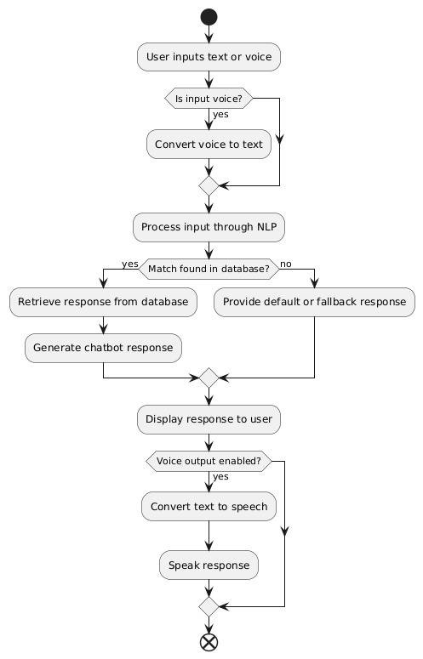

IMPLEMENTATION
6.1 Sample Code

import os
import nltk
import ssl
import streamlit as st
import random
import pyttsx3
import speech_recognition as sr
from sklearn.feature_extraction.text import TfidfVectorizer
from sklearn.linear_model import LogisticRegression

# SSL context fix for nltk
ssl._create_default_https_context = ssl._create_unverified_context
nltk.data.path.append(os.path.abspath("nltk_data"))
nltk.download('punkt')

intents = [
{
"tag": "greeting",
"patterns": ["Hi", "Hello", "Hey", "How are you", "What's up"],
"responses": ["Hi there", "Hello", "Hey", "I'm fine, thank you", "Nothing much"]
},
{
"tag": "goodbye",
"patterns": ["Bye", "See you later", "Goodbye", "Take care"],
"responses": ["Goodbye", "See you later", "Take care"]
},
{
"tag": "thanks",
"patterns": ["Thank you", "Thanks", "Thanks a lot", "I appreciate it"],
"responses": ["You're welcome", "No problem", "Glad I could help"]
},
{
"tag": "exam_schedule",
"patterns": [ "When are the semester exams?", "Exam timetable", "Exam schedule" ],
"responses": [ "The semester exams start from 10th May 2025. Check the official website or notice board for updated exam timetables."],
},
]

# Create the vectorizer and classifier
vectorizer = TfidfVectorizer()
clf = LogisticRegression(random_state=0, max_iter=10000)

# Preprocess the data
tags = []
patterns = []
for intent in intents:
for pattern in intent['patterns']:
tags.append(intent['tag'])
patterns.append(pattern)

x = vectorizer.fit_transform(patterns)
y = tags
clf.fit(x, y)

def speak(text):
engine = pyttsx3.init()
engine.say(text)
engine.runAndWait()
engine.stop()

def recognize_speech():
recognizer = sr.Recognizer()
with sr.Microphone() as source:
st.write("Listening...")
audio = recognizer.listen(source)
try:
return recognizer.recognize_google(audio)
except sr.UnknownValueError:
return "Sorry, I could not understand your speech."
except sr.RequestError:
return "Sorry, my speech service is down."

def chatbot(input_text):
input_text = vectorizer.transform([input_text])
tag = clf.predict(input_text)[0]
for intent in intents:
if intent['tag'] == tag:
response = random.choice(intent['responses'])
speak(response)
return response

def main():
st.title("COLLEGE CHATBOT FOR VISITORS/GUESTS")
st.write("Welcome! Type your message or use the voice input.")

# Text input
user_input = st.text_input("You (text):")

# Voice input button
if st.button("Use Voice Input"):
user_input = recognize_speech()
st.write(f"You (voice): {user_input}")

# Process input and generate response
if user_input:
response = chatbot(user_input)
st.text_area("Chatbot:", value=response, height=100, max_chars=None)

if response.lower() in ['goodbye', 'bye']:
st.write("Thank you for chatting with me. Have a great day!")
st.stop()

if __name__ == '__main__':
main()

OUTPUT SCREENS
7. OutPut Screens:

TESTING

8.1 Introduction to Testing
Testing is a crucial phase in the software development life cycle (SDLC) that ensures the system functions correctly and meets user requirements. The goal of testing is to identify defects, verify functionality, and validate that the software performs as expected under various conditions. In this project, testing is essential for ensuring the accuracy of vehicle detection and counting.
Testing involves different methodologies, including:
- Unit Testing: Testing individual components of the system.
- Integration Testing: Ensuring different modules work together correctly.
- System Testing: Validating the complete system against requirements.
- Performance Testing: Checking the system's speed and responsiveness.
- User Acceptance Testing (UAT): Ensuring the system meets the end-users' expectations.
For this project, testing focuses on verifying video input processing, vehicle detection accuracy, real-time tracking efficiency, and error handling.

8.2 Sample Test Cases

Test Case 1: Greeting Message

Test ID | TC001
Description | Verify that the chatbot responds correctly to a greeting message
Input | "Hello"
Expected Output | "Hi there" or "Hello" or similar greeting response
Actual Output | (To be filled after testing)
Status | Pass/Fail

Test Case 2: Exam Schedule Query

Test ID | TC002
Description | Check if the chatbot provides exam schedule details
Input | "When are the semester exams?"
Expected Output | "The semester exams start from 10th May 2025. Check the official website or notice board for updated exam timetables."
Actual Output | (To be filled after testing)
Status | Pass/Fail

Test Case 3: Thanks Response

Test ID | TC003
Description | Verify that the chatbot responds correctly to a thank-you message
Input | "Thank you"
Expected Output | "You're welcome" or "No problem"
Actual Output | (To be filled after testing)
Status | Pass/Fail

Test Case 4: Unrecognized Input Handling

Test ID | TC004
Description | Ensure the chatbot provides a fallback response for unknown inputs
Input | "Tell me a joke"
Expected Output | "Sorry, I don't understand that." (or a default response)
Actual Output | (To be filled after testing)
Status | Pass/Fail

Test Case 5: Voice Input Recognition

Test ID | TC005
Description | Verify that the chatbot can process voice input correctly
Input | User speaks "Hello" using microphone
Expected Output | "Hi there" or "Hello"
Actual Output | (To be filled after testing)
Status | Pass/Fail

Test Case 6: Voice Output Functionality

Test ID | TC006
Description | Check if the chatbot correctly converts text response to speech
Input | "Hello"
Expected Output | Chatbot speaks "Hi there"
Actual Output | (To be filled after testing)
Status | Pass/Fail

Test Case 7: Exit Command

Test ID | TC007
Description | Ensure the chatbot exits when the user says "Goodbye"
Input | "Goodbye"
Expected Output | "Thank you for chatting with me. Have a great day!" and chatbot stops execution
Actual Output | (To be filled after testing)
Status | Pass/Fail

CONCLUSION
9. Conclusion
The Design and Development of a College Chatbot for Visitors/Guests Using Python aims to provide an efficient, user-friendly, and interactive platform for visitors seeking information about a college. The chatbot leverages Natural Language Processing (NLP), Speech Recognition, and Machine Learning to understand and respond to user queries effectively.
Through the implementation of the TF-IDF vectorizer and Logistic Regression classifier, the chatbot can accurately classify user input and provide appropriate responses. By integrating Streamlit, a lightweight web framework, the chatbot ensures easy accessibility for users via a web interface.

Key Achievements
- Developed a text- and voice-based chatbot to assist college visitors.
- Integrated Speech Recognition for hands-free user interaction.
- Implemented Machine Learning for improving response accuracy.
- Created a user-friendly web interface using Streamlit.
- Incorporated structured intent classification to handle multiple user queries.

Limitations and Future Enhancements
While the chatbot provides a strong foundation for handling visitor inquiries, there are several areas for future improvement:
- Expansion of Knowledge Base: The chatbot can be enhanced by integrating a dynamic college database for real-time updates.
- Multilingual Support: Future versions could include support for multiple languages to cater to diverse users.
- AI-powered Conversational Improvements: Incorporating Deep Learning models (e.g., Transformers, BERT, GPT) can enhance the chatbot’s ability to understand complex queries.
- Mobile Application Integration: The chatbot can be deployed as a mobile application for greater accessibility.
- Live Chat Support: Human-in-the-loop functionality could be added, allowing users to escalate queries to live support if needed.
In conclusion, this project successfully demonstrates the potential of AI-powered chatbots in providing automated assistance to college visitors. By leveraging modern technologies, this chatbot can serve as an efficient virtual assistant, reducing the workload of administrative staff and enhancing the overall user experience.

REFERENCE
10. References
- D. Geron, Hands-On Machine Learning with Scikit-Learn, Keras, and TensorFlow, O'Reilly Media, 2019.
- R. Hartley and A. Zisserman, Multiple View Geometry in Computer Vision, Cambridge University Press, 2003.
- PlantUML Documentation - https://plantuml.com/
- IEEE Transactions on Intelligent Transportation Systems - https://ieeexplore.ieee.org/
- Scikit-learn for Machine Learning – https://scikit-learn.org/
- NumPy Official Guide - https://numpy.org/doc/
- Streamlit Framework - https://docs.streamlit.io/
- Python Official Documentation - https://docs.python.org/
- SpeechRecognition Library – https://pypi.org/project/SpeechRecognition/
- NLTK (Natural Language Toolkit) Documentation – https://www.nltk.org/

Books & Research Papers
- Jurafsky, D., & Martin, J. H. (2020). Speech and Language Processing (3rd Edition). Pearson.
- Manning, C., & Schütze, H. (1999). Foundations of Statistical Natural Language Processing. MIT Press.
- Goldberg, Y. (2016). A Primer on Neural Network Models for Natural Language Processing. Journal of Artificial Intelligence Research, 57, 345-420.
- Brownlee, J. (2020). How to Develop a Chatbot from Scratch Using Python. Machine Learning Mastery.
- Towards Data Science. (2021). Building a Conversational AI Chatbot with Python & NLP. https://towardsdatascience.com/

